PROJECT BASED LEARNING

Alfred Solis

Alfred Solis
2861 Womble Road
San Diego, CA 92106
619.944.9299 mobile



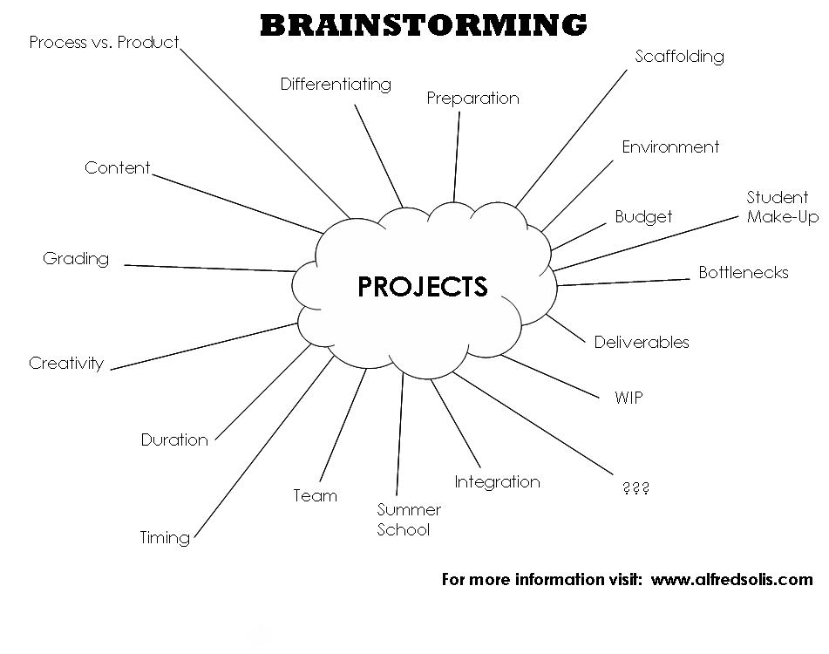

PROJECT DEVELOPMENT SHEET

CONTENT
STANDARDS | RIGOR | COLLEGE PREP | REFERENCES | INTERDISCIPLINARY
RESOURCES
STUDENTS | MATERIALS* | TIME | YOURSELF | OTHERS**
BUDGET
PROCESS
TEAM | DOCUMENTING | REVISION | DIFFERENTIATION | SCAFFOLDING
PRODUCT
ENGAGEMENT | DELIVERABLES | ASSESSMENT | PORTFOLIO | EXHIBITION

* Hardware, Software, Classroom, Building, & Bottlenecks ** Peers, Staff, Parents, Partners, & Special Needs
PROJECT DEVELOPMENT EXPRESS

PROJECT NAME:
PRINCIPLE | DESCRIPTION | IDEAS
ACADEMIC RIGOR | Projects address key learning standards identified by the school or district and helps students develop habits of mind and work associated with academic and professional disciplines.
AUTHENTICITY | Projects use a real world context (e.g., community and workplace problems) and address issues that matter to the students.
APPLIED LEARNING | Projects engage students in solving semi-structured problems calling for competencies expected in high-performance work organizations (e.g. teamwork, problem-solving, communication, etc.).
ACTIVE EXPLORATION | Projects extend beyond the classroom and connect to work internships, field-based investigations, and community explorations.
ADULT CONNECTIONS | Projects connect students with adult mentors and coaches from the wider community.
ASSESSMENT PRACTICES | Projects involve students in regular exhibitions and assessments of their work in light of personal, school and real-world standards of performance.

NOTES

_______________________________________________________________________________________________________________________________________

_______________________________________________________________________________________________________________________________________

_______________________________________________________________________________________________________________________________________

_______________________________________________________________________________________________________________________________________

Math & Physics Syllabus

Welcome to HTH. Please take the time to review this syllabus with your parents. All students are also responsible for its content. Please keep in mind that due to the nature of project-based learning the syllabus is subject to change. Do not forget to sign, detach, and return the Student & Parent Agreement (page 3).

For updated/additional information, please visit my Digital Portfolio at
www.alfredsolis.com

Teacher InfoRMATION
  Alfred Solis | Office/Room: 14
  High Tech High  2861 Womble Road  San Diego, CA 92106-6025  619-243-5000  www.hightechhigh.org | Email: asolis@hightechhigh.org  Office Phone: 619-243-5003  Mobile Phone: 619-944-9299 (Emergencies Only)  Fax: 619-243-5050
teacher  Background | I grew up in San Diego amongst a myriad of Filipino navy families. I went to college at Cal Poly San Luis Obispo graduating with Honors in Mechanical Engineering. Ultimately, I chose a career with a Big 4 Firm doing business/internet consulting and later joined a Bay Area Venture Fund. HTH allows me to bring all my professional and personal passions into the classroom, which should hopefully result in an interesting and exciting year.
REQUIRED MATERIALS | All students must bring to class everyday the following materials:  - An effective organizational system  - College ruled paper  - Pencil with an eraser  - Scientific calculator // i.e. Texas Instruments TI-30X IIS ($14.00)
COURSE  DESCRIPTION | At HTH, we are focused on personalized education, real-world learning, and a common intellectual mission that is primarily achieved through project-based learning. Students will achieve HTH core curriculum objectives, their own personal objectives, and transitional objectives during the following topics listed below. For student digital portfolios, visit www.projectht.com.
  Math I  - Algebra Operations  - Linear (First Order) Equations  - Quadratic (Second Order Equations)  - High Order Equations  - Triangles & Trigonometry  - Circles & Analytic Geometry  - Waves  - Datametrics  - Probability & Statistics  - Measurement & Estimations | Physics I  - Motion & Forces  - Mechanics  - Momentum  - Energy  - Electricity  - Heat  - Magnetism  - Sound & Light
TENTATIVE WEEKLY SCHEDULE | Note: Algebra Operations, Datametrics, Probability & Statistics, Measurement & Estimations will be covered throughout the Semesters. Furthermore, holiday weeks were omitted from the schedule.
  Semester 1 |  | Semester 2
  Wk | Topic | Wk | Topic
  1 | Assessment/Linear Equations | 1 | Quadratics/Energy
  2 | Linear Equations/Motion | 2 | Quadratics/Energy
  3 | Linear Equations & Geo./Motion | 3 | Quadratics/Energy
  4 | Linear Eqs. & Geo./Motion & Forces | 4 | Impulse & Momentum
  5 | Linear Eqs. & Geo./Motion & Forces | 5 | Impulse & Momentum
  6 | Geometry & Trig./Motion & Forces | 6 | Electricity
  7 | Geometry & Trig./Motion & Forces | 7 | Electricity
  8 | Geometry & Trig./Motion & Forces | 8 | Electricity
  9 | Friction, Torque, Pulleys, & Mech. | 9 | Electricity
  10 | Friction, Torque, Pulleys, & Mech. | 10 | Electricity
  11 | Friction, Torque, Pulleys, & Mech. | 11 | Waves & Exhibition
  12 | Friction, Torque, Pulleys, & Mech. | 12 | Heat & Magnetism
  13 | Friction, Torque, Pulleys, & Mech. | 13 | Sound & Light
  14 | Presentations of Learning (POLs) | 14 | STAR Testing
  15 | Intersession | 15 | Final Project
  16 | Intersession | 16 | Final Project
   |  | 17 | Final Project
   |  | 18 | Final Project
   |  | 19 | POLs
   |  | 20 | POLs
GRADING SYSTEM | Note:  - Classwork is graded for completeness (70%) and neatness (30%).  - Late Classwork will be accepted, but assignments lose 10% per day it is late down to 50% off where it will remain fixed for the duration of the class.  - Passing Presentations of Learning (POLs) are required for transition.
  Grading Breakdown:  30% Exams & Quizzes  30% Projects & Presentations  20% Classwork  20% Participation & Behavior  100% | Grading Scale:  90% + is an A (+/-)  80-89% is a B (+/-)  70-79% is a C (+/-)  69% - is not passing
GUIDELINES FOR BEHAVIOR | All students have the right to learn in an environment conducive to learning. Demonstration of maturity and mutual respect will be the guiding principles for classroom conduct. The following are general behavior guidelines:  - Respect yourself, the rights of others, and property.  - Be punctual and prepared.  - Maintain your focus on the subject and the instructor.
SUGGESTED RESOURCES | Applied Physics: Crash Course by Schaum's Easy Outlines ($8.95)  Algebra I by CliffsQuickReview ($9.99)  Algebra II by CliffsQuickReview ($9.99)  Geometry by CliffsQuickReview ($9.99)  Trigonometry by CliffsQuickReview ($9.99)  The New SAT Math Workbook by Kaplan ($17.00)

Graph It Design Duration: 3-4 weeks

The “Graph It Design” Project  The goal of the Graph It Design is to have students walk the fine line between objectivity and subjectivity when it comes to works of art created by Ancient Civilizations (3000 B.C. - 500 A.D.). The students will reinvent an image into its basic linear form, which will allow them to determine what is essential to a masterpiece.  Scope of Work  Every team of two (2) students is responsible for creating a linear graph on Microsoft Excel of an artifact dating back to the Ancient World.  Deliverables  Original Image  Hand-plotted Image  Connect the Dots  Excel Table & Graph  Master Action Plan  Work In Progress (WIP) Meetings & Emails  Individual Digital Portfolio | 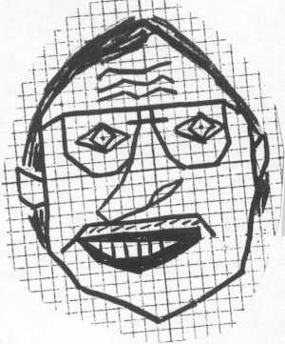  Note: Mr. Aguirre does not qualify as an Ancient Artifact
Requirements
The Original Image must:
-- Be an approved historical artifact (i.e. painting, sculpture, structure, pottery, jewelry, etc.)
-- Be from an Ancient Civilization (3000 B.C. - 500 A.D.)
-- Be maximized on an 8.5" by 11" piece of paper
The Hand-plotted Image must:
-- Have a washed out version of the Original Image
-- Have a detailed grid with X- & Y-axis
-- Have defined points with connecting lines
-- Have at least 180 lines
-- Have the X- & Y-axis centered on the image
-- Have a combination of horizontal, vertical, positive/negative sloped lines
-- Exceeding Expectations: Have a few shaded areas with the use of inequalities
Connect the Dots must be completed before moving onto the Excel Graph.
The Excel Table & Graph must:
-- Show all the fixed (x) and generated (y) values of the points on the table
-- Have all the points and lines on the graph
-- Have the Table and Graph on separate tabs
-- Be titled and labeled
-- Be stylized using available tools
-- Have the artist names
-- Exceeding Expectations: Using the table calculate the total length of ALL the lines
The Master Action Plan must:
-- Have ALL detailed items for the successful completion of the project
-- Reflect weekly benchmarks via the dates
-- Have team member assignments
The Work In Progress (WIP) Meetings & Emails must:
-- Have an up-to-date Master Action Plans PRINTED/ATTACHED
-- Establish completion of Weekly Benchmarks
-- Express via email or during private meetings regarding WIP problems with partnerships
The following benchmarks are to be completed by the end of the respective week.
WEEK | BENCHMARK(S)
1 | Understanding of Proposal & Initial Master Action Plan, Choose Original Image
2 | Complete Hand-plotted Image and Connect the Dots
3 | Finish Excel Table & Graph, Finalize Portfolio

The Digital Portfolio must:
-- Include the Location, History, & Description of the artifact
-- Explain the process step by step with images, links, and text
-- Post the Original & Hand-plotted images
-- Have working hyperlinks to the Excel Table & Graph and Final Master Action Plans
-- Have a reflection covering "what went well, what could you do better, & what did you learn about yourself" in regards to the project itself AND the partnership

Grading Criteria
The students will be working in teams of two (2), but they will each receive an individual grade. The varying weights for the following criteria will determine their overall score.
-- Thoughtfulness & Thoroughness
-- Work Ethic & Behavior
-- Deadlines & Deliverables
-- Exceeding Expectations
Additional Info
The Seven Wonders of the Ancient World
Greek Anphora
Name ____________________________

______ /100 points
Math CWK #1 Connect the Dots

Use the following steps & equations to fill in the table for at least 180 lines drawn for the “Graph It Design” project. Clearly show ALL of your work on a separate sheet of paper. Do not use decimals or calculators.

STEP 1: Choose any one (1) line through two (2) points: A (x₁, y₁) & B (x₂, y₂)

STEP 2: Find the slope, m, of the line: $m=\frac{y_{2}−y_{1}}{x_{2}−x_{1}}$

STEP 3: Identify what type of line it is: horizontal, vertical, or positive/negative slope

STEP 4: Solve for the equation of the line:

- If the line has a positive or negative slope, then put in y-intercept form, y = mx + b

- If the line is horizontal, then find the y-intercept, b, and put in y = b

- If the line is vertical, then find the x-intercept, a, and put in x = a

STEP 5: Repeat the steps at least 180 times (Equally divide the work among partners)

HINT: Assign one partner with Quadrants I & III and the other with Quadrants II & IV

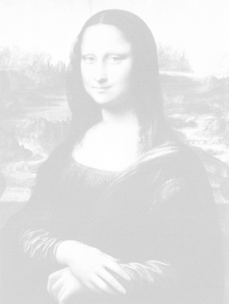
QUAD I
QUAD II
QUAD III
QUAD IV

Name ____________________________

Reprint this page as many times as you need to.

 | STEP 1 |  | STEP 2 | STEP 3 | STEP 4
# | A (x₁, y₁) | B (x₂, y₂) | m | Type | Equation of the Line
1 | ( , ) | ( , )
2 | ( , ) | ( , )
3 | ( , ) | ( , )
4 | ( , ) | ( , )
5 | ( , ) | ( , )
6 | ( , ) | ( , )
7 | ( , ) | ( , )
8 | ( , ) | ( , )
9 | ( , ) | ( , )
10 | ( , ) | ( , )
11 | ( , ) | ( , )
12 | ( , ) | ( , )
13 | ( , ) | ( , )
14 | ( , ) | ( , )
15 | ( , ) | ( , )
16 | ( , ) | ( , )
17 | ( , ) | ( , )
18 | ( , ) | ( , )
19 | ( , ) | ( , )
20 | ( , ) | ( , )
21 | ( , ) | ( , )
22 | ( , ) | ( , )
23 | ( , ) | ( , )
24 | ( , ) | ( , )
25 | ( , ) | ( , )

Name ____________________________

______ /50 points

Math CWK #2 Distance Formula

Use the following equations to answer the questions. Clearly show ALL of your work.

Equations:

Pythagorean Theorem | Distance Formula
$$c^{2}=a^{2}+b^{2}$$ | $$d=\sqrt{(x_{2}−x_{1})^{2}+(y_{2}−y_{1})^{2}}$$

Q1) Prove the Distance Formula, using the Pythagorean Theorem.

Q2) Using the distance formula, choose 8 lines from Graph It Design and solve for the distances.

# | A (x₁, y₁) | B (x₂, y₂) | QUAD | Type | Distance
1 | ( , ) | ( , ) | I | Positive
2 | ( , ) | ( , ) | I | Negative
3 | ( , ) | ( , ) | II | Positive
4 | ( , ) | ( , ) | II | Negative
5 | ( , ) | ( , ) | III | Positive
6 | ( , ) | ( , ) | III | Negative
7 | ( , ) | ( , ) | IV | Positive
8 | ( , ) | ( , ) | IV | Negative

Challenge Problem (Additional 40 points)

Using the following figure and similar triangles, prove the Pythagorean Theorem.

A
C
B
T

Master Action Plan

Team Name: Madalyn and Matt

PROPOSAL → Design → Preparation → Build → Test → Finalize
REVISE

 |  | ASSIGNED TO
# | ITEM | Matt | Madalyn | Both
1.0 | PROPOSAL
1.1 | Understanding Project Sheet |  |  | x
1.2 | Determine Artifact |  |  | x
1.3 | Save an original image file | x
1.4 | Bring image into word | x
1.5 | Maximize and washout in Word | x
1.6 | Get Approval by Alfred |  |  | x
2.0 | DESIGN
2.1 | Draw X and Y axis |  | x
2.2 | Draw Dots or Grid Lines |  |  | x
2.3 | Draw Lines | x
2.4 | Make sure we have at least 180 dots |  |  | x
2.5 | Line Plotting |  |  | x
2.6 | Figure out Equations |  |  | x
3.0 | PREPARATION
3.1 | Excel Training |  |  | x
3.2 | DP Training |  |  | x
4.0 | BUILD
4.1 | Inputting points for quadrants 1 & 3 | x
4.2 | Inputting points for quadrants 2 & 4 |  | x
4.3 | Draw Remaining Lines |  | x
5.0 | TEST
5.1 | Master action plan |  |  | x
5.2 | Reflection |  |  | x
5.3 | History of artifact |  | x
5.0b | REVISE
5.1b | Checking all work and fixing mistakes | x
6.0 | FINALIZE
6.1 | Axis adjusting |  |  | x
6.2 | Coloration/beautification | x

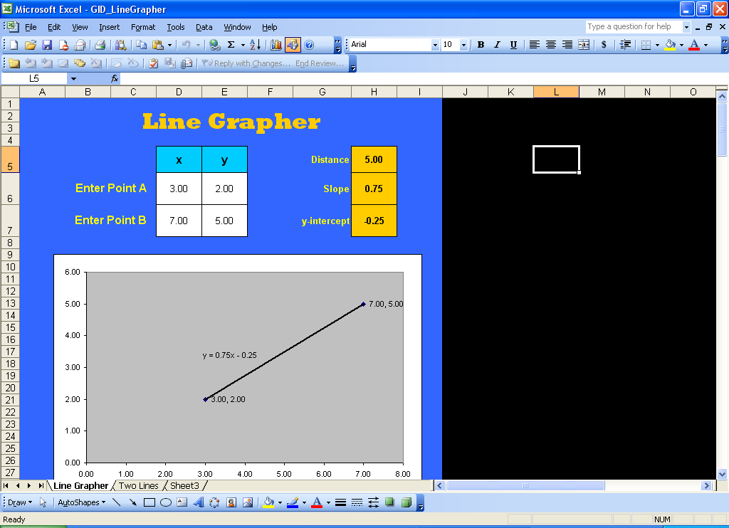
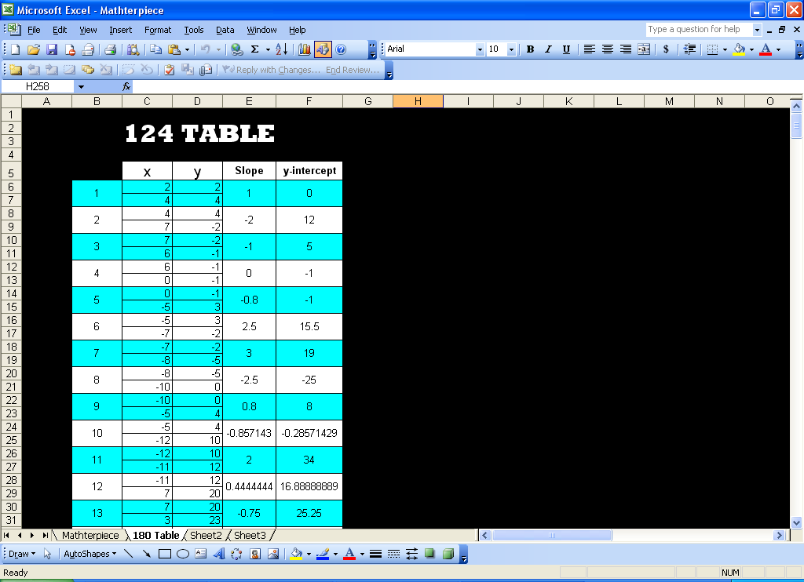
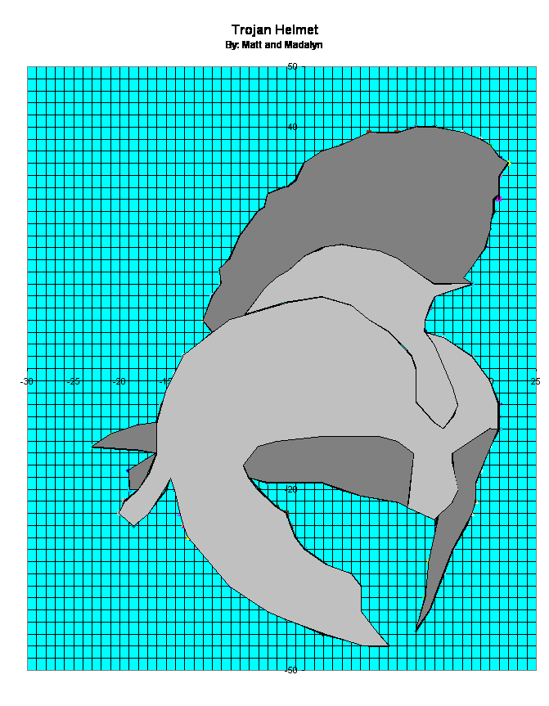

Eggstreme Sports Duration: 5 days

The “Eggstreme Sports” Project  The goal of Eggstreme Sports is to help students understand how a simple mechanical spring and free falling from a platform can be an educational and extreme experience. The students will create a bungee jump for eggs and learn that Math & Physics is all that it's cracked up to be.  Scope of Work  A pair of students will create a bungee jump from rope and rubber bands that drops an egg from over 20 ft. The goal is to get as close as possible to the floor without breaking shell. The students must do the necessary calculations to solve for the spring constant (k) of the bungee rope. The following materials & tools will be provided for analysis:  -- Rubber Bands  -- Rope  -- Weights  -- Duct Tape Harness  -- Tape Measure  -- Accuscale  -- Microsoft Excel  -- Two Story Mechanic Lift | 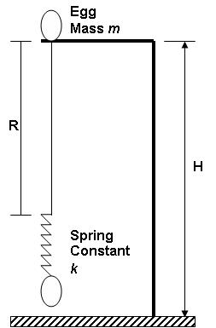
Deliverables
Rubber Band Spring – Students will be creating their very own bungee rope.
By-Hand & Excel Graphs – Students will be graphing the spring constant (Force vs. Displacement) by hand and with software.
Eggstreme Challenge – Students will be proving Newton's Laws with the use of Trigonometry.
Live Test Run – The Students will be given only one (1) chance to make it or break it during the bungee jump.
Master Action Plan is not required, but highly reccommended.
Individual Digital Portfolio is also not required, but highly reccommended.
Requirements
The Rubber Band Spring must:
-- Have the team names written on it
-- Use ALL 1/4 pound of rubber bands
-- Have a calculated spring constant k
-- Have hook up loops on both ends
-- Note: The spring constant of the rope is negligible
The By-Hand & Excel Graph must:
-- Be turned in individually for the By-Hand Graph and together for the Excel Graph
-- Include a Descriptive Title with labeled Y- & X-axis including Units
-- Have ten (10) data points recorded on the Data Collection Sheet
-- Note: Do not forget to put team names on graph
Eggstreme Challenge must be completed and mastered before the Live Test Run.
The Live Test Run must get as close as possible to the ground without hitting. Students who can solve for the theoretical stretch of the spring on their own will receive bonus points.
Grading Criteria
The following criteria will determine the overall individual grade.
-- Thoughtfulness & Thoroughness
-- Deadline & Deliverables
-- Work Ethic & Behavior
-- Bonus Points goes to Teams that get closer than a foot from the floor. That's Eggstreme!
Safety
By participating in Eggstreme Sports, the students are agreeing to all the safety issues discussed in class.
Additional Info
See Eggstreme Sports Handout

Name ____________________________

______ /20 project points

Physics CWK #4 Eggstreme Challenge

List of Materials:  - Rubber Band Bungee with Spring Constant  - Metal Washer  - Duct Tape | - Accuscale  - Tape Measure  - Lead Block

FOLLOW THE STEPS:

In order to receive the initials for completion, every team member must show competency. Be prepared to answer questions. Show ALL your work on a separate sheet of paper.

Initials

______ 1. Securely hang one end of your Rubber Band Bungee. Attach the provided known weight at other end. Record displacement.
    - Draw the Free Body Diagram (FBD) of the Static system
    - Using Newton’s Law, calculate the theoretical displacement
    - How does the actual displacement compare with the theoretical displacement?
    - Does the hand-plot or Excel graph yield a better theoretical result when compared to the actual?

______ 2. Using Duct Tape and the Floor, secure two team’s Rubber Band Bungees to a Metal Washer. Have the Bungees pulling the washer in opposite directions.
    - Draw the Free Body Diagram (FBD) of the Static system
    - Using the other team’s actual displacement & Newton’s Law, calculate your team’s theoretical displacement

______ 3. Using Duct Tape and the Floor, secure three team’s Rubber Band Bungees to the Metal Washer at various angles to create a Static system.
    - Draw the Free Body Diagram (FBD) of the Static system
    - Using Vector Addition & Newton’s Law, prove that the system is Static.

______ Eggstreme Eggstreme Challenge (+10 project points) Using Duct Tape and the Floor, secure three team’s Rubber Band Bungees to the Mystery Accuscale and Lead Block. Using Trigonometry and Newton’s Law, determine what the Accuscale should read.

Once you have completed the challenge, then you are cleared for a Live Test Run. If you really want to challenge yourself, then ask to see the Eggstreme Sports Handout. Try to understand it…it’s EGGSTREME!!!

Pool Table Challenge

Names __________________________________________

In order to participate in the pool tournament, every team member must show competency. Be prepared to answer questions.

PART 1: MOMENTUM

Steps:

1) Using the triple-beam scale, find the mass (in kilograms) of the golf ball
h
v

m = g = kg

2) Using the PVC tube and elbow joint, find the height (in meters) that allows the golf ball to roll and stop without hitting any rails

Height = m

3) Find the potential energy (in joules) of the golf ball

P.E. = mgh = J

4) Find the kinetic energy (in joules) of the golf ball

K.E. = ½mv² = J

5) Find the initial velocity (in meters per second) of the golf ball

v = m/s

6) Find the momentum of the golf ball

mv = kg·m/s

7) Using vector addition and two (2) golf balls, prove the conservation of momentum.




Extreme Challenge: Using vector addition and three (3) golf balls, prove the conservation of momentum.
PART 2: ENERGY LOSS

Steps:

1) Using the same height in Part 1, measure the distance (in meters) traveled without hitting a rail

S_{traveled}

S_{Traveled} = m

2) Calculate the the amount Work (in joules) done by friction to bring the golf ball to rest

W_{Friction} = P.E. = J = F•s

3) Calculate the Average Friction Force (in Newtons)

F_{Friction} = N

4) Using the same height in Part 1, have the golf ball hit the rail and measure the total distance traveled, which is the distance traveled to the rail plus the “bounce back” distance.

S_{Traveled} = m

5) Calculate the energy loss due to hitting the rail

W_{Rail} = F_{Friction} • (New S_{Traveled} – Old S_{Traveled}) = J

6) Calculate the percent energy loss due to hitting the rail

% Energy Loss = [(W_{Friction} - W_{Rail})/ W_{Rail}] x 100 = %

Ring My Bell Challenge

Name __________________________________________

In order to participate in the Carnival, every team member must show competency. Be prepared to answer questions.

PART 1: FIND IMPULSE RATIO

Steps:

1) Label the above figure with the following: F₁, F₂, r₁, r₂, & τ

2) Measure the following lengths of your actual lever arm

r₁ = | r₂ =

3) Derive the ratio of the forces and impulses (Assume: Δt₁ = Δt₂)

$$\frac{F_{1}}{F_{2}}=$$ | $$\frac{P_{1}}{P_{2}}=$$
PART 2: COMPARING THEORETICAL & ACTUAL HEIGHT

Steps:  1) Label all the variables on the figure to the right.  2) Using the triple-beam scale, find the mass (in kilograms) of the puck.  m_{puck} = g = kg  3) Calculate the KE after dropping a _________ kg bag of rice onto the lever arm  h_{bag} = m  KE_{bag} = J  4) Calculate momentum of the rice bag  V_{bag} = m/s  (mv)_{bag} = kg•m/s  5) Calculate the momentum of the puck after the lever arm applies a force for a given amount of time  (mv)_{puck} = kg•m/s  6) Calculate the maximum Kinetic Energy of the puck  KE_{max} = J  7) Calculate the theoretical height of the puck  PE_{max} = J  h_{theoretical} = J  8) After getting permission from Alfred, actually get the rice bag and drop it from the predetermined height and measure how high the puck actually travels  h_{actual} = J | 9) Calculate the percent energy loss  % Energy Loss = [(PE_{max} – PE_{actual})/ PE_{max}] x 100 = %  10) List possible causes of energy loss:

Operation 1492 Challenge

Names: _____________________________ _____________________________

_____________________________ _____________________________

List of Materials:  - Alligator Clips  - 1.5-3.0 Volt DC Motor  - “AA” Battery Holder with 2 AA Batteries | - LED Assembly with Built-In Resistor  - Wire  - Electrical Tape

FOLLOW THE STEPS:

In order to receive the initials for completion, every team member must show competency. Be prepared to answer questions.

Initials

______ 1. Set up a SERIES circuit using one (1) battery source, one (1) motor, and one (1) alligator clip. Remember too much potential difference could fry the motor.
    - Note if the motor is spinning CW or CCW and how fast it is spinning. Hint: Attach a piece of tape on the end of the motor.
    - Switch the wires attached to the motor. What do you notice about the direction the motor is spinning?
    - When is the circuit OPEN or CLOSED?

______ 2. Set up a SERIES circuit using one (1) battery source, one (1) LED assembly, and one (1) alligator clip. The built-in resistor is making sure the LED doesn’t burn out.
    - Note how bright the LED is shining
    - Is the resistor need for this circuit?

______ 3. Add one (1) motor to the SERIES circuit in Step 2.
    - Does the motor appear to be spinning faster or slower when compared to the circuit in Step 1?
    - Does the LED appear to be shinning brighter or dimmer than the circuit in Step 2?

______ 4. Set up a PARALLEL circuit using one (1) battery source, one (1) motor, one (1) LED assembly, and two (2) alligator clips.
    - Disconnect the motor and check if the LED is still lit
    - Disconnect the LED and check if the motor is still spinning
    - Every team member must draw & label ALL electronic components with proper graphical representation along with the potential differences (ΔV), resistances (Ω), & currents (I) for the PARALLEL circuit schematic. If possible, check your theoretical values with the actual readings of the multi-meter. Remember, sharing is a virtue.

______ 5. Using parts from another group. connect a COMPLEX circuit that uses both SERIES & PARALLEL.

Once you have completed the challenge, then you can practice soldering at the specified areas. Don’t forget to wear your goggles.

Pipe Dreams

Names: _________________________ _________________________ _________________________

List of Materials:  - 1/2” Electrical Conduit (1.5ft)  - Electronic Chromatic Tuner  - Hacksaw & C Clamps  - Sandpaper & Wood Blocks | - Rubber band & Popsicle Sticks  - Tape Measure  - Goggles  - Masking Tape

Determining Lengths

First, it's usually not practical to exactly predict what note a given length of a given material will produce. You have to take into account all sorts of physical properties of the material, which aren't easy to determine. The good news is, once you make the Reference Pipe, and find out what note it plays, you can accurately predict any other length/pitch for the same material. "Basic Acoustics" by Donald E. Hall points out that for two bars being identical except in their lengths, their frequencies are related as:

$$L_{2}=L_{1}×\sqrt{\frac{F_{1}}{F_{2}}}$$

Where:
L₁ = Length of your Reference Pipe (in inches)
F₁ = Note it plays (in Hz)
F₂ = Note you want the next pipe to play (in Hz)
L₂ = Length to which you'll have to cut the next bar (in inches)
For example: say you've got an electrical conduit 12" long, and it plays "D" at 587 Hz (You might have to trim a little off this first pipe to get it to play a "real" note. Remember that a short pipe gives a higher pitch than a longer pipe.) You want to make another pipe which sounds the "A" at 880 Hz. Provided you use the same kind of pipe (that means the same material, same width), you'll get your "A" from a pipe 9.8" long.
Finding Frequencies

Here's three octaves' worth, from an even-tempered scale based on A=440. (If you're looking to use a different temperament, you're on your own.) If you need to go to the next octave up, multiply the frequency by 2. Similarly, to go down an octave, divide the frequency by 2.

C : 261.63 C : 523.25 C : 1046.50
C#: 277.18 C#: 554.36 C#: 1108.73
D : 293.66 D : 587.33 D : 1174.66
Eb: 311.13 Eb: 622.25 Eb: 1244.51
E : 329.63 E : 659.26 E : 1318.51
F : 349.23 F : 698.46 F : 1396.91
F#: 369.99 F#: 739.99 F#: 1479.98
G : 392.00 G : 783.99 G : 1567.98
G#: 415.30 G#: 830.61 G#: 1661.22
A : 440.00 A : 880.00 A : 1760.00
Bb: 466.16 Bb: 932.93 Bb: 1864.66
B : 493.88 B : 987.77 B : 1975.53

# | Length (inches) | Frequency (Hz) | Musical Note
Ref.
1
2
3
4
5
6
7
8
9
10
11
12
13
14
15
16
17
18
19
20

Toga Night Theatre Positions

POSITION | RESPONSIBILITIES AND DUTIES
Director | The Director:  - Knows and understands the priorities and the artistic, financial, and educational objectives  - Makes artistic choices (i.e. set design, blocking, & casting) as well as organizational choices (i.e. rehearsal schedule)  - Keeps an eye on the future and doesn’t become so immersed in day-to-day matters that they lose sight of their goal  - Knows that a theatrical production continually changes and evolves  - Can create and foster a sense of urgency and excitement  - Reports to the Producers
Assistant Director | The Assistant Director:  - Not only gives input to the Director, but also executes casting & staffing and tracks the rehearsal schedule  - Is the liaison between the Director and the Cast, Costume Designer, Makeup Designer, and Proper Master/Mistress  - Maintains the Prompt Script for line/scene changes, blocking, and cues  - Reports to the Director
Production Stage Manager | The Production Stage Manager:  - Expedites the artistic intentions of the director in all areas of the production  - Oversees the design, build, and test of the Stage Designs  - Give input on the staffing of Set Designers, Lighting Designer, and Assistant Stage Manager  - Maintains the Technical Cues List  - Manages the Technical Rehearsals  - Reports to the Director
Assistant Stage Manager | The Assistant Stage Manager:  - Not only gives input to the Production Stage Manager, but also executes the design staffing and tracks the project schedule  - Is the liaison between the Production Stage Manager and the Set Designers, Lighting Designers, and Stage Crew  - Maintains the Technical Cues List and cross checks cues with Assistant Director  - Reports to the Production Stage Manager
Publicist | The Publicist:  - Staffs the proper talent to design and create the programs and invitations  - Reports to the Producers
House Manager | The House Manager:  - Prepares the seating layout for the theatre  - Maintains a professional and welcoming environment for the audience  - Manages the Ushers  - Reports to the Producers
Catering Services | The Catering Services:  - Orders the food and drinks for the event  - Manages the Food Servers  - Reports to the Producers

Exam Review #1

The Exam will be on Friday, October 5, 2007.

Test Materials
- Pencil & Eraser
- Calculator
- Cheat Sheet
- Notes & Homework
- Book To Read

MATH

Orders of Operations

Equation Manipulation

Triangles
- Isosceles, Equilateral
- Congruent & Similar (Scale Factor)
- Special Triangles
- Angles, Area, & Perimeter
- Rulers & Protractors

Right Triangles
- Trigonometry
- Pythagorean Theorem

Sine Waves
- Amplitude
- Frequency
- Phase
- Degrees & Radians

Challenges

PHYSICS

Pipe Dreams

Waves
- Transverse vs. Longitudinal
- Mechanical vs. Electromagnetic
- Constructive vs. Destructive Interference
- Period & Wave Speed
- Real Life Examples

Challenges
Exam #4a

Calculators and cheat sheets are allowed, but you must show ALL your work. NO WORK, NO POINTS. Do not forget the UNITS. Good luck ☺

Question 1) A battery is wired to a switch and an LED with a built-in resistor. The LED lights up when the circuit is closed by the switch. However, when a second LED is wired to the circuit neither LED lights up after closing the switch. (20 points)

Use the following space to explain the problem with the circuit and a potential solution.

________________________________________________________________________

________________________________________________________________________

________________________________________________________________________

________________________________________________________________________

________________________________________________________________________

________________________________________________________________________

________________________________________________________________________

________________________________________________________________________

________________________________________________________________________

________________________________________________________________________

________________________________________________________________________

________________________________________________________________________

________________________________________________________________________

________________________________________________________________________

________________________________________________________________________

Question 4) Three resistors are connected in series to an 18-volt battery. The first resistor is rated at 8 ohms, the second at 12 ohms, and the third at 16 ohms. (25 points):

The following questions are for the above circuit.
a) Draw and label the schematic
b) Find the combined resistance
c) Find the current
d) Find the potential difference across the 12 ohm resistor
e) Find the power dissipated by the 12 ohm resistor

CHALLENGE: If you solve the problem with the same resistors in parallel, then you will receive an additional 5 bonus points.
TPOL RUBRIC-9TH grade
Aguirre Solis Team
Semester Two 2006/2007

Before presenting your TPOL to the panel you must be prepared with the following:

- 6 artifacts on your DP | YES | NO
- One 5x7 notecard | YES | NO
- Thesis paper | YES | NO
- Appropriate Dress | YES | NO

You will be graded on your TPOL based on the following rubric:

 | Max Points | Final Score
COMMUNICATION/PRESENTATION SKILLS:
▪ Presents ideas/requirements in an organized/logical way | 3
▪ Voice has proper volume, rate, clarity and vitality | 3
▪ Uses professional language and posture | 3
▪Engages the audience with eye contact and gestures | 3
HUMANITIES content defense (discuss 3 separate topics & answer content question(s)):
▪ Choose 1 topic to discuss growth in reading & answer question(s) | 10
▪ Choose 1 topic to discuss growth in writing & answer question(s) | 10
▪ Choose 1 topic to discuss growth in critical thinking & answer question(s) | 10
MATH/PHYSICS content defense (discuss 3 separate topics & answer content question(s)):
▪ Choose 1 topic to discuss growth in critical thinking & answer question(s) | 10
▪ Choose 1 topic to discuss growth in analysis & answer question(s) | 10
▪ Choose 1 topic to discuss real world application of math/science & answer question(s) | 10
TRANSISTION TO 10th GRADE
▪ Clearly and articulately describes and defends why he/she should move on to the 10th grade. May include examples of growth, responsibility, goals, etc. | 3
TOTAL POINTS: | 75

Math & Science Content Questions

CRITICAL THINKING
Marvelisk
- How did torque and center of gravity play a role in the success or failure of the system design?
  - Draw the Free Body Diagram (FBD) and use equations to support your claims
  - Explain the physics (compression & tension) behind a triangle

GEOperation
- Explain a specific circuit problem that was overcome while creating the game.
  - Draw the schematic of the circuit used for the game
  - Circuit Challenge

ANALYSIS
Graph It Design
- What are the slopes of given multiple sets of data points?
  - Describe different types of lines (positive, negative, horizontal, vertical, etc.)
  - Find the slopes of the lines that are parallel and perpendicular
- What is the slope-intercept form of the line for given data points?
  - Graph the line
  - Know how to graph inequalities (>, <, ≥, ≤)

Eggstreme Sports
- What is the Spring Constant (K) for given data points? Explain the graph.
- Calculate values for a falling body (distance, velocity, & acceleration equations)

Pole-verize
- Ring My Bell Challenge
  - Give a high level explanation (highlighting equations) of how the pole-verizer works
  - Be prepared to solve problems concerning torque, impulse, momentum, and/or energy

GEOperation
- Calculate the values for your game’s schematic when given data values.
  - Calculate the new current if resistors were added to the circuit
  - Calculate the power used by any resistor in the circuit

First Order (Linear) Equations
- Solve for two (or three) equations or two (or three) unknowns
  - Graph the solution for 2X2 only
  - Explain the solution

Second Order (Quadratic) Equations
- Explain the discriminant and solve for the roots of a given equation
- Using completing the square, derive the standard form of the parabola (graph).

Waves
- Graph given sine waves
- Discuss the amplitude, frequency, wavelength, and period of the graphs

REAL WORLD APPLICATION (TACO SALAD)

