Name ____________________________

______ /50 points

Math HWK #14 Golden Ratio, Pascal’s Triangle, & Probability

Show your work on a separate sheet of paper and box your answers.

1. Solve for x of the Golden Ratio.

$\frac{1}{x}=\frac{x}{1+x}$

2. What is the next bottom row of the Pascal Triangle?

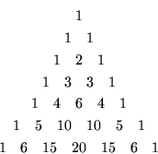

3. When tossing a penny, what are your chances of getting heads four times in a row? What are your chances of not getting heads three times in a row?

4. A bag has 5 blue marbles, 7 red marbles, and 9 black marbles. What is the probability of pulling a black marble and then a blue marble out of the bag?

Challenge Problem (Additional 25 Bonus Points)

C1. At a certain riding school, students are randomly assigned to the horses they will use during any given lesson. The school has exactly 5 male horses and 6 female horses. If there are exactly 3 women and 8 men in the class, what is the probability that a student will be assigned a horse of the same sex?

