Graph It Design Duration: 3-4 weeks

The “Graph It Design” Project  The goal of the Graph It Design is to have students walk the fine line between objectivity and subjectivity when it comes to works of art created by Ancient Civilizations (3000 B.C. - 500 A.D.). The students will reinvent an image into its basic linear form, which will allow them to determine what is essential to a masterpiece.  Scope of Work  Every team of two (2) students is responsible for creating a linear graph on Microsoft Excel of an artifact dating back to the Ancient World.  Deliverables  Original Image  Hand-plotted Image  Connect the Dots  Excel Table & Graph  Master Action Plan  Work In Progress (WIP) Meetings & Emails  Individual Digital Portfolio | 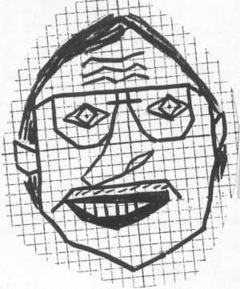  Note: Mr. Aguirre does not qualify as an Ancient Artifact
Requirements
The Original Image must:
-- Be an approved historical artifact (i.e. painting, sculpture, structure, pottery, jewelry, etc.)
-- Be from an Ancient Civilization (3000 B.C. - 500 A.D.)
-- Be maximized on an 8.5" by 11" piece of paper
The Hand-plotted Image must:
-- Have a washed out version of the Original Image
-- Have a detailed grid with X- & Y-axis
-- Have defined points with connecting lines
-- Have at least 180 lines
-- Have the X- & Y-axis centered on the image
-- Have a combination of horizontal, vertical, positive/negative sloped lines
-- Exceeding Expectations: Have a few shaded areas with the use of inequalities
Connect the Dots must be completed before moving onto the Excel Graph.
The Excel Table & Graph must:
-- Show all the fixed (x) and generated (y) values of the points on the table
-- Have all the points and lines on the graph
-- Have the Table and Graph on separate tabs
-- Be titled and labeled
-- Be stylized using available tools
-- Have the artist names
-- Exceeding Expectations: Using the table calculate the total length of ALL the lines
The Master Action Plan must:
-- Have ALL detailed items for the successful completion of the project
-- Reflect weekly benchmarks via the dates
-- Have team member assignments
The Work In Progress (WIP) Meetings & Emails must:
-- Have an up-to-date Master Action Plans PRINTED/ATTACHED
-- Establish completion of Weekly Benchmarks
-- Express via email or during private meetings regarding WIP problems with partnerships
The following benchmarks are to be completed by the end of the respective week.
WEEK | BENCHMARK(S)
1 | Understanding of Proposal & Initial Master Action Plan, Choose Original Image
2 | Complete Hand-plotted Image and Connect the Dots
3 | Finish Excel Table & Graph, Finalize Portfolio

The Digital Portfolio must:
-- Include the Location, History, & Description of the artifact
-- Explain the process step by step with images, links, and text
-- Post the Original & Hand-plotted images
-- Have working hyperlinks to the Excel Table & Graph and Final Master Action Plans
-- Have a reflection covering "what went well, what could you do better, & what did you learn about yourself" in regards to the project itself AND the partnership

Grading Criteria
The students will be working in teams of two (2), but they will each receive an individual grade. The varying weights for the following criteria will determine their overall score.
-- Thoughtfulness & Thoroughness
-- Work Ethic & Behavior
-- Deadlines & Deliverables
-- Exceeding Expectations
Additional Info
The Seven Wonders of the Ancient World
Greek Anphora

